ASSIGNMENT NO. 7
Support Vector Machine (SVM) for Regression

Aim
To implement Support Vector Regression (SVR) and compare how different kernels handle curved data.

Objectives
- Understand how SVM ideas carry over to regression.
- Learn what the epsilon tube and support vectors are.
- Understand what kernels and the parameters C, epsilon and gamma do.
- Compare linear, polynomial and RBF kernels on the same data.

Software and tools
Python 3, written and run in Jupyter Notebook (VS Code works too) on Windows. Libraries used: numpy, matplotlib and scikit-learn.

Theory

1. SVM in brief
SVM is best known as a classifier. It draws a line (a hyperplane, in more dimensions) between two classes so that the gap to the nearest points on each side, called the margin, is as wide as possible. Those nearest points are the support vectors, since they're the ones holding the line in place.

2. Support Vector Regression
SVR uses the same idea to predict numbers. Ordinary linear regression tries to shrink every point's error. SVR is more relaxed. It draws a tube of width ε (epsilon) around its line, and any point inside the tube counts as close enough, with no penalty. Only points outside the tube count as errors.
In SVR, the support vectors are the points on the edge of the tube or outside it. They alone decide where the line goes. Points sitting inside the tube could be deleted and the model wouldn't change.

3. What SVR minimises
SVR keeps the line as flat as it can while fitting most points inside the tube:
Minimise ½‖w‖² + C · Σ (ξᵢ + ξᵢ*)
such that | yᵢ − f(xᵢ) | ≤ ε + ξᵢ
w is the weight of the line, and ξ (xi) are slack values that measure how far a point lies outside the tube.

4. Main parameters
Parameter | What it controls
C | How hard points outside the tube are punished. High C hugs the data, low C keeps the model smoother.
epsilon (ε) | Width of the tube. A wider tube ignores more small errors.
kernel | The kind of shape the model can fit (linear, poly, rbf).
gamma | Used by the RBF kernel. High gamma makes the curve wiggly, low gamma makes it smoother.

5. The kernel trick
A straight line can't follow curved data. Kernels get around this by treating the data as if it had been moved into a higher dimension where a straight fit works, without ever computing that dimension. The common ones are:
- Linear: K(x, x′) = x · x′, which gives a straight line.
- Polynomial: K(x, x′) = (x · x′ + 1)ᵈ, a curve of degree d.
- RBF (Gaussian): K(x, x′) = exp(−γ ‖x − x′‖²), which can fit almost any smooth shape.

6. Strengths and weaknesses
SVR does well on small and medium datasets, handles curves through kernels, and isn't thrown off much by a few outliers, since small errors inside the tube are ignored. It's slow on very large datasets, needs C, epsilon and gamma tuned, and is harder to explain than linear regression. Features should normally be scaled first. Our program has a single feature between 0 and 5, so we skipped scaling.

Dataset used
We generated 100 points with numpy. x is random between 0 and 5, and y is sin(x) plus a little noise. The curved shape makes the difference between a straight-line kernel and the curved ones easy to see. 75 points were used for training and 25 for testing.

Procedure
- Import numpy, matplotlib and the scikit-learn modules.
- Generate the sine-shaped data with some noise.
- Split it into training and testing sets.
- Create three SVR models with linear, polynomial and RBF kernels.
- Train each one, predict the test data and print MSE and R².
- Plot all three prediction curves over the data.
- Print how many support vectors the RBF model used.

Program
# Assignment 7 - Support Vector Regression (SVR)
import numpy as np
import matplotlib.pyplot as plt
from sklearn.svm import SVR
from sklearn.model_selection import train_test_split
from sklearn.metrics import mean_squared_error, r2_score

# make a curved (sine shaped) dataset with a little noise
rng = np.random.RandomState(0)
X = np.sort(5 * rng.rand(100, 1), axis=0)
y = np.sin(X).ravel() + rng.normal(0, 0.15, 100)

X_train, X_test, y_train, y_test = train_test_split(X, y, test_size=0.25, random_state=0)

models = {
'Linear': SVR(kernel='linear', C=10),
'Polynomial': SVR(kernel='poly', degree=3, C=10),
'RBF': SVR(kernel='rbf', C=10, gamma=0.5, epsilon=0.1),
}

plt.figure(figsize=(7, 4))
plt.scatter(X, y, s=12, color='gray', label='Data')
line_x = np.linspace(0, 5, 200).reshape(-1, 1)

print("Kernel MSE R2")
for name, model in models.items():
model.fit(X_train, y_train)
y_pred = model.predict(X_test)
print(f"{name:11s} {mean_squared_error(y_test, y_pred):7.4f} {r2_score(y_test, y_pred):6.3f}")
plt.plot(line_x, model.predict(line_x), label=f'{name} kernel')

print("\nSupport vectors used by RBF model:", len(models['RBF'].support_))

plt.xlabel('X')
plt.ylabel('y')
plt.title('SVR with different kernels')
plt.legend()
plt.tight_layout()
plt.savefig('a7_svr.png')
plt.show()

Output
Kernel MSE R2
Linear 0.3320 0.275
Polynomial 0.1468 0.680
RBF 0.0327 0.929

Support vectors used by RBF model: 43

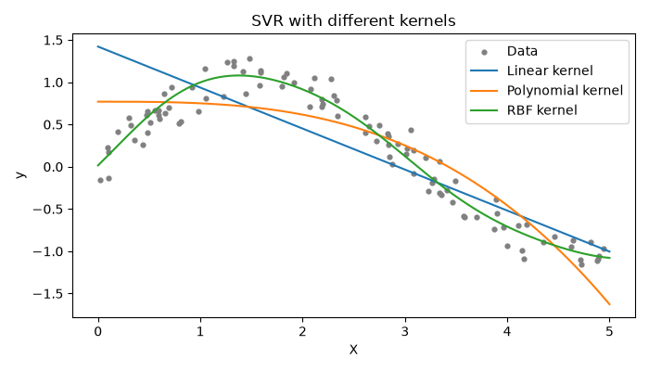
Figure 7.1: SVR predictions with three different kernels

Observations
- The linear kernel did worst (R² = 0.275). A straight line can't follow a sine wave.
- The polynomial kernel did better (R² = 0.680). It bends, but misses the curve at the start and falls too steeply at the end.
- The RBF kernel was best by a wide margin, with R² = 0.929 and MSE = 0.0327. Its curve follows the data closely.
- The RBF model used 43 of the 75 training points as support vectors. The other 32 sat inside the epsilon tube and had no effect on the curve.

Conclusion
On curved data the RBF kernel fit far better than the polynomial kernel, and the linear kernel couldn't capture the pattern at all. With SVR, the choice of kernel matters more than anything else, and the right one lets it model relationships that plain linear regression can't.

